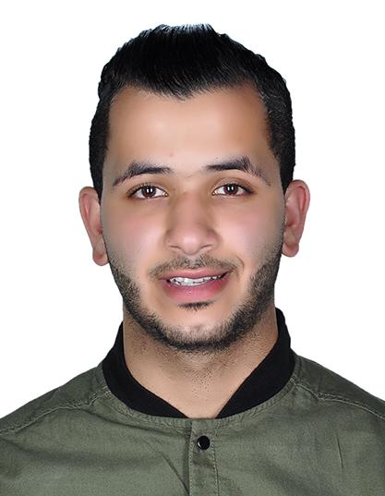  
 **Mohammed Fadhul**

**Curriculum Vitae**

**PERSONAL DETAILS**

Birth: 08/06/1999

Address: House:1735 Road: 641 Sanabis 406

Phone: 00973 - 39007400

Email: [hamo0od17@live.com](mailto:hamo0od17@live.com)

**EDUCATION**

**Primary & Intermediate Certificate** 2005 – 2014

The Jaafary Religious Institute

**Secondary Certificate**  2015 – 2018

Jedhafs Secondary Boys Industrial School

**Direct English Level 1.2** 2018 – 2019

Tylos Human Development

**WORK EXPERIENCE**

Administration 2017 – To Date

Marawey Car Services

Arranging Job Card, bringing spare parts, make invoices, following overdue payments & Monthly payments.

**SKILLS**

*Language* Arabic ( Mother Tongue)

English (Average)

*Software*  Office 2010

**REFERENCES**

Available upon request